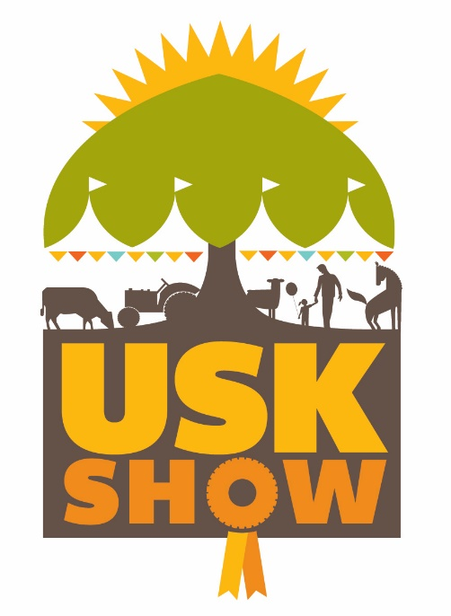
SHOW TIMETABLE 2022
9:00am Show Opens to the Public, Trade Stands Open, Horse Judging and Show Jumping Commences
9:30am Entries CLOSE for Homecraft & Horticulture Sections
10:00am Judging for other Sections Commences (Marquees may be closed to the Public while Judging takes place)
11:00am Companion Dog Show Entries Open, Horticulture Marquee Opens to the Public
12:00pm Companion Dog Show Judging Starts
12:30pm Homecraft & Poultry Marquees Open to the Public

Main Ring

10:00am Horse Classes - Retraining of Racehorse, Side Saddle Costume Concours d’Élégance
11.00am Emergency Services Display
12.00pm Children & Horse Fancy Dress Competition
12.15pm Steam Section Display
12.30pm The Cavalry of Heroes
1.15pm Curre & Llangibby Hunt
1.45pm Usk Valley Working Gundog Display
2.15pm Emergency Services Display
3.15pm Grand Parade of Livestock
4.00pm The Cavalry of Heroes
4.45pm Inter Hunt Relay

Countryside Ring

10:00am Usk Valley Working Gundog Display
10.30am Black Mountains Falconry
11.00am The Ferguson Club: Working Vintage Machinery
11.45am Rockwood Dog Agility Team
12.15pm Rowan Working Horses
1.00pm Amazing Alpacas
1.30pm Woolaston Bassett Hounds
2.00pm Vintage Tractor Parade
2.45pm Black Mountains Falconry (Horseback Display)
3.15pm Usk Valley Working Gundog Display
3.45pm Rockwood Dog Agility Team
4.15pm Rowan Working Horse Display

