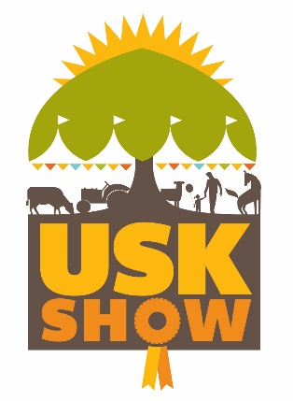
Usk Show Inter Hunt Relay Challenge
10th September 2022
Commencing in the main ring at approx. 4.30pm

Entry Fee: £60 per team

Rules
Teams to consist of 4 riders, who are active members of the Hunt or Pony Club they represent. Correct attire for autumn hunting.
Competition to be run as a relay against the clock.
A Baton (Hunting whip) must be exchanged over to the next competitor, inside the start box.
10 second time penalty added if handover is outside the start box.
5 seconds time penalty for a knock down of a fence.
Refusals- no penalty but if in trouble the next competitor can finish their round before their own.
One team member to be under 18 years of age but over 12 years and at least one member to be of opposite sex to the others.

Prize Money
1st Place £100 & A days hunting with The Curre & Llangibby Hunt.
2nd Place £60
3rd & 4th Team rosettes
Best Turned Out Team Prize money £40

JUDGES DECISION IS FINAL

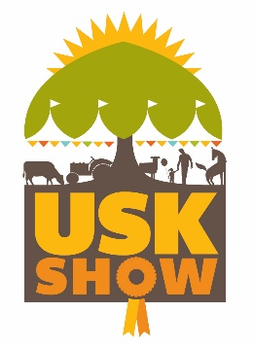
Usk Show Ground, Gwernesney, Nr Usk, NP15 1DD
USK SHOW – INTER HUNT RELAY CHALLENGE ENTRY FORM
Entries close 29th August 2022

Please send entry forms to Nia Osborne (Event Manager) at the below addresses
Email: Secretary@uskshow.co.uk
Post: Usk Farmers Club Ltd, Llancayo Farm, Gwehelog, Usk, Monmouthshire, NP15 1HY
Team Name:
Name of Hunt

Name & address of entry contact  Including email |  | Age | Name of Horse | £60  Per  Team
Contact Telephone No.
Name of Team Member 1.
Name of Team Member 2
Name of Team Member 3
Name of Team Member 4

One team member to be under 18 years of age but over 12 years and at least one member to be of opposite sex to the others.
BACS – preferable method (Please state as a reference your Team name)
Sort Code: 20 00 85 Account: 60896861 Account name: Usk Farmers Club Ltd
Cheques made payable to: Usk Farmers Club Ltd

Signed:…………………………………………………. Date:………………………………………
Please note that Admission passes will be emailed, NOT posted

