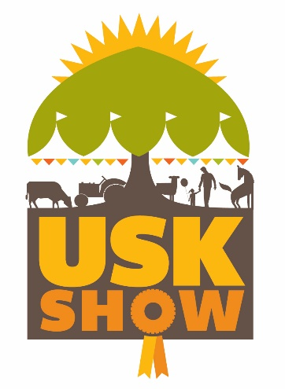
Usk Farmers’ Club Ltd
Llancayo Farm
Gwehelog
Usk
Monmouthshire
NP15 1HY
Tel: 01291 690889
Email: secretary@uskshow.co.uk

Usk Farmers’ Club Membership

Thank you for your interest. By joining Usk Farmers' Club you are becoming a member of one of the oldest Agricultural Societies in the UK, supporting our community and the Usk Show.
Become a Member and enjoy the following benefits: -

Ordinary Membership - £50 | Vice President Membership - £75
- Free Admission for Two Adults to the Show  - Privileged use of the Members' Ringside Enclosure & Bar  - Opportunity to entertain guests in the Members Enclosure  - Access to members restaurant where you can purchase Breakfasts or lunches  - Exclusive toilets in Members’ enclosure  - Free Tea & Coffee on presentation of your badge at the coffee bear situated near the members enclosure  - Annual Agricultural or Horse Schedule  - Free Entry in all Agricultural Classes  - Receipt of Annual Accounts  - Attend and vote at General Meetings of the Club  - Details of our Social Events | - Free Admission for Two Adults to the Show  - Privileged use of the Members' Ringside Enclosure & Bar  - 2 x Guest passes to entertain guests in the Members Enclosure (N.B. This does not include entry to the show)  - Voucher for a Show Catalogue  - Forward Car Parking Permit  - Access to members restaurant where you can purchase Breakfasts or lunches  - Exclusive toilets in Members’ enclosure  - Free Tea & Coffee on presentation of your badge at the coffee bear situated near the members enclosure  - Annual Agricultural or Horse Schedule  - Free Entry in all Agricultural Classes  - Receipt of Annual Accounts  - Attend and vote at General Meetings of the Club  - Details of our Social Events

Please note that either level of membership can be purchased as a single membership for a 50% reduction, but you will only receive 1 x admission pass (& 1 guest pass for VP)

To benefit from Membership for 2023 please complete the form below and return with payment to the Secretary by 31st July 2023

I wish to become an Ordinary Member / Vice President * of Usk Farmers' Club Limited for 2023. I would like a Livestock / Horse* Schedule sent to me annually. (* delete as appropriate)

NAME

ADDRESS

POSTCODE

EMAIL TELEPHONE

SIGNED DATE

Your details are held by Usk Farmers Club Ltd for legitimate reasons only. We will not pass your details onto any third party. Data held for you can be requested from secretary@uskshow.co.uk at any time or requested to be removed.

Payment details:
BACS Payments preferred Sort Code 20 00 85 Account Number 20897132 Account Name Usk Farmers Club Ltd
Cheques made payable to Usk Farmers Club Ltd

